Southeastern Michigan Veterans Stand Down, Inc.

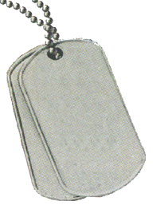
11 &12 October 2023 (9:00 AM – 5:00 PM)
(Veteran Registration Closes at 1:00 PM)

Volunteer Registration – 7:00 AM

This year’s Stand Down will be held at:
Fellowship Chapel Banquet and Conference Center
7707 W. Outer Drive
Detroit, Michigan 48235

Stand Down Set-up (Volunteers): October 10, 2023 (9:00 AM – 5:00 PM)

Volunteers and vendors/support agencies
Can register on the Website.
Questions
Please Contact:
President:
Norm ‘Gunny’ Wilcox
- 808-0929

1st Vice President

Geoffrey Devereaux
313 595-1262

www.4vets.org

“For honor, Duty and Country…We Leave No Veteran Behind.”
Giving a “hand up” not a “hand out”
To our Homeless and low-income Veterans

